**ZRO justice-based vision for blockchain blueprint**

Zorro is essentially using blockchain technology to try to solve various pain points in the industry and build a "global blockchain free trade area ". The Zorro provides the underlying block chain infrastructure and introduces Zorro Token system as a measure of the value transmission of trade activities between small and medium-sized merchants. under various application scenarios, Zorro will work with numerous third-party service agencies around the world to create a platform that integrates e-commerce payment, e-commerce supply chain traceability, e-commerce supply chain finance, e-commerce community live broadcast, e-commerce data digital money exchange.



Zorro hope that with the idea of digitization, non-tampering distributed timestamp system and ubiquitous, interconnected, real-time chain business system, properly achieve the above grand goals, truly achieve all-round, full coverage of fairness, justice, to provide strong support for the realization of the highest goal of "all human freedom ".



The Zorro will be implemented in steps to provide services such as prompt arrival, quick payment, cross-border payment, currency exchange, traceability of information, etc., in response to the existing pain points in the e-commerce market mentioned above; further services, including local incubation services and services to issue regional Token on Zorro, can be expanded in the future.

Zorro design takes full account of openness and compliance and will comply with local regulatory requirements and regulations. due to the openness of the Zorro blockchain, regulation can set up nodes on it when necessary, or provide transaction records through Zorro. Because the block chain can not tamper characteristics, which will fully help regulation improve its regulatory accuracy when necessary.



Imagine you can trade with a stranger without trusting him; you can safely store your savings there without trusting the bank; you don't need to trust the government because you know it has to be fair and just. What will happen then?

That will change the world.

And that is the vision of the blockchain.

While mainstream media are still busy speculating about the price of cryptocurrency and its black-market plot, they have left out the essence of all this. That is, cryptographers quietly invented a new set of technological prototypes. Block chains (and consensus protocols that support them) were born out of developers trying to solve a problem bold puzzle: how to create an untraceable digital currency. By combining cryptography, game theory, economics, and computer science, they have succeeded in creating a whole new set of tools building decentralized systems. But their creation is far more than changing the way money is exchanged, but more. Their creation will change the whole world, and that seems to be unnoticed.

[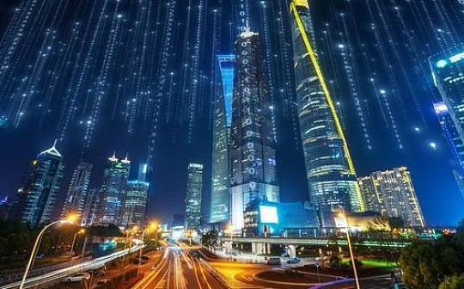](https://www.jinse.com/news/blockchain/614703.html)

And the founding vision of the ZRO platform, is to achieve this grand vision. ZRO, is essentially using blockchain technology to try to solve various pain points in the industry and build a "global blockchain free trade area ". The ZRO provides the underlying block chain infrastructure in the FTAA and introduces the ZRO token system as a measure of the value transmission of trade activities between small and medium-sized merchants. Along with many third-party services around the world, ZRO will create a collection of e-commerce payments, e-commerce supply chain traceability, e-commerce supply chain finance, e-commerce community live, e-commerce data digital money exchange as one of the application scenarios Body platform.

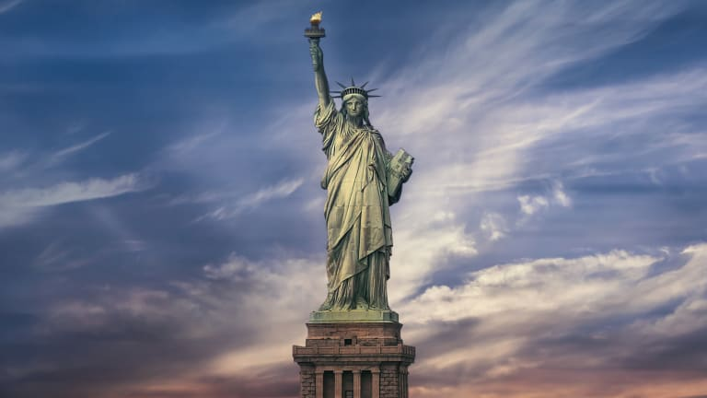

ZRO hope that with the idea of digitization, non-tampering distributed timestamp system and ubiquitous, interconnected, real-time chain business system, properly achieve the above grand goals, truly achieve all-round, full coverage of fairness, justice, to provide strong support for the realization of the highest goal of "all human freedom ".

ZRO will be implemented in steps to provide services such as prompt arrival, quick payment, cross-border payment, currency exchange, traceability of information, etc., in response to the existing pain points in the e-commerce market mentioned above; further services, including local incubation services and ZRO distribution areas, can be extended in the future the service of sexual tokens, etc.

ZRO design takes full account of openness and compliance and will comply with local regulatory requirements and regulations. due to the openness of the ZRO blockchain, regulation can set up nodes on it when necessary, or provide transaction records through ZRO. Due to the non-tampering nature of the blockchain, the move will fully help regulation improve its regulatory accuracy when necessary.



Block chain is no longer far away, has come to reach the immediate point, it is part of the Internet, in transportation, medical care, clothing industry, property rights, payment, life services and other areas have appeared a lot of application scenarios, block chain let the Internet wave upgrade again, and gradually into more innovative areas. in the field of digital money. Block chain is not only a kind of technological innovation, but also reveals the possibility of constructing a new economic model. In the field of value empowerment and transfer, blockchain technology has begun to show great advantages because of its open, transparent, traceable and non-tampering characteristics, and finally, It will help us complete the value transfer of the digitization of assets and realize the real control of our own wealth.